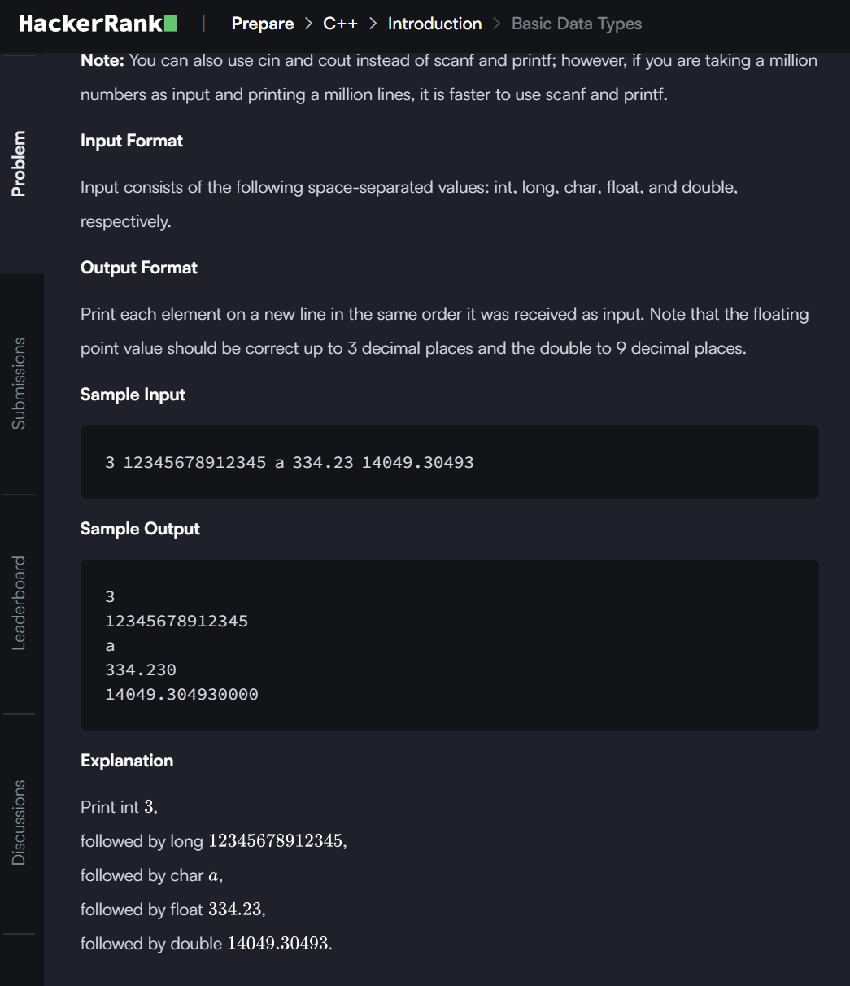

**ANSWER**

#include <iostream>

#include <iomanip>

using namespace std;

int main() {

int a;

    long b;

    char c;

    float d;

    double e;

    cin>>a>>b>>c>>d>>e;

    cout<<a<<endl;

    cout<<b<<endl;

    cout<<c<<endl;

    cout<<fixed<<setprecision(3)<<d<<endl;

    cout<<fixed<<setprecision(9)<<e<<endl;

    return 0; }